Denboer Holdings Pty. Ltd.  2 Waterview Parade,  Redcliffe.  Western Australia. 6104.  AUSTRALIA. | Perth | Phone : 61 8 9277 6441  Fax : 61 8 9277 4151  Mobile : 61 419 577 644  Email : annbram@westnet.com.au  Thursday, July 30, 2026

ABN 87 204 280 671

Subject New term deposit in the name of Spencer Stacey Superannuation Fund.
ABN 33 650 674 642

Dear Spencer,
Please be advised that as of today the 1st of July 2019, we have received the sum of $605,000 Six hundred and five thousand dollars to be invested with us for a period of twelve months.

Funds will be invested on Monday the 3rd and interest will be payable at 3.26% monthly, interest is accrued & added to the investment monthly.

Funds are invested in First mortgages by our Company and are secured by way of registered First Mortgages by Denboer Holdings Pty Ltd.

Trust this meets with your approval,

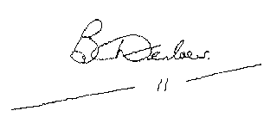Yours sincerely,

B Denboer Executive Director

