Superannuation & Corporate Services Pty Ltd
Suite 802 Level 8 309 Pitt Street Sydney NSW 2000

26 May 2020

Private and Confidential

The Trustee,
Heperu Employees Superannuation Fund
83 Wentworth Road,
VAUCLUSE NSW 2030

Dear Sir / Madam,

RE: AUDIT MANAGEMENT LETTER

I wish to advise that the audit of the Heperu Employees Superannuation Fund for the year ended 30 June, 2019 has recently been completed.

Auditors are encouraged by the Australian Taxation Office to issue management letters at the completion of each audit as a means of advising the trustee of any matters noted during the course of the audit.

My audit work involves examination, on a test basis, of evidence supporting the amounts and other disclosures in the financial report in order to form an opinion as to whether, in all material respects, the financial report is fairly stated in accordance with the accounting policies described in the notes thereto. Further, my audit work involves examination, again on a test basis, of evidence supporting compliance with certain requirements of the Superannuation Industry (Supervision) Act 1993 and the Superannuation Industry (Supervision) Regulations 1994 (“SIS”).

I advise that I have not encountered any matters during the course of the audit that I believe should be brought to your attention.

Should you wish to discuss the above, please do not hesitate to contact the undersigned.

Yours faithfully,
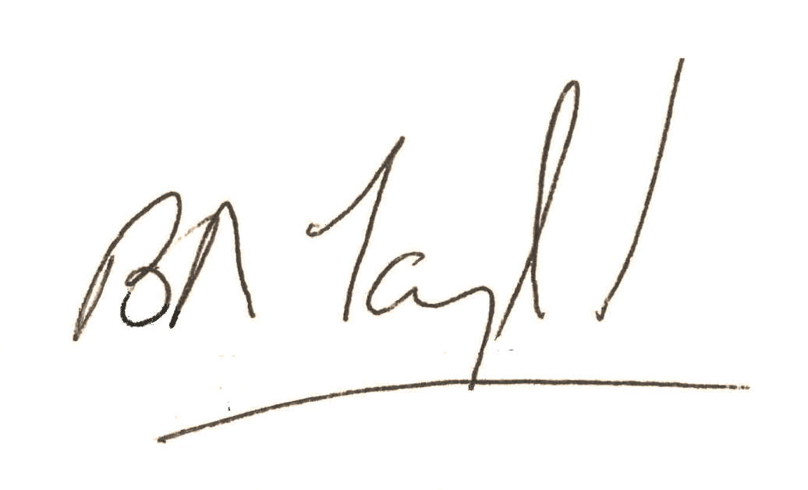

Brian Taylor
Auditor

