Audit query – PT & LJ Vicary SF – 2023 year

The Halifax Trader Work Station portfolio has been frozen for a number of years due to it going into liquidation. That was finalised in 2023FY and the money returned. The actual reporting, though, is only available up to the 2022FY.

That portfolio is now fully cleared in the 2023FY.

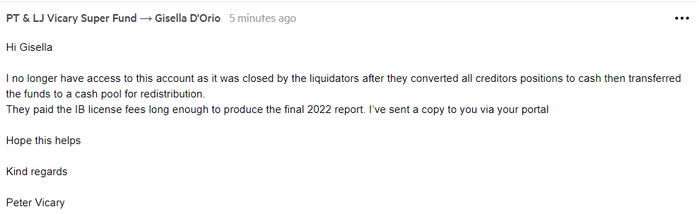

There are no new permanent records since the last audit.