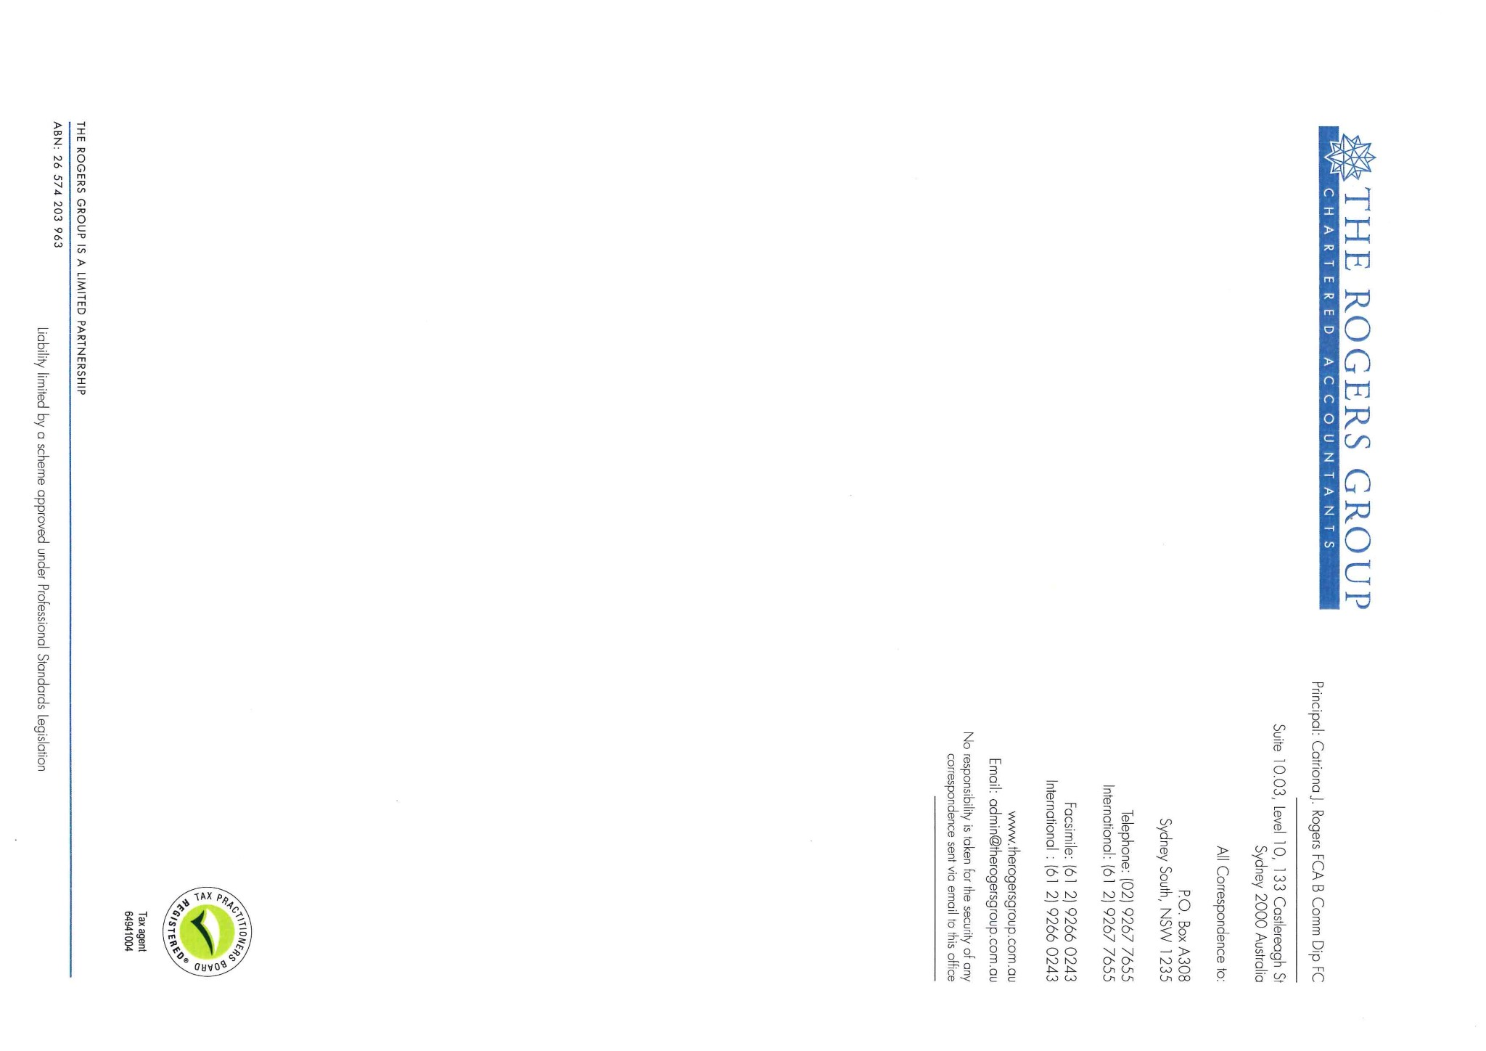

22 February 2021

The Directors

Penrith Nominees (NSW) Pty Limited

13 Worcester Street

**COLLAROY NSW 2097**

**melgilmartin@hotmail.com**

Dear Melissa,

**Penrith Nominees (NSW) Pty Limited - 129 794 298**

**ANNUAL COMPANY STATEMENT**

Please find enclosed the Annual Company Statement now required to be lodged for the abovenamed. This is required to be lodged by 20 April 2021.

We have reviewed the Company Register of Directors and Register of Shareholders and confirm that the Annual Company Statement correctly reflects the information shown in the Registers.

The statement has been reviewed and the details appear correct. However please check carefully and advise if any of the details are in fact incorrect and the required paperwork will be prepared and forwarded to you for your signature. Please retain the Annual Company Statement for your records.

The Directors of the company are required to pass a solvency resolution each year within 2 months of the review date. This resolution confirms that your company has the ability to pay its debts as and when they fall due. The attached resolution should be signed and returned to our office.

The 2021 annual fee required by ASIC is $55.00. Please note that this amount is not subject to GST and is payable by the due date 20 April 2021.

Please also note that heavy penalties will be imposed by ASIC if the Company Statement is not lodged by the due date. A late fee of $80.00 for payments up to one month late can be charged, increasing to a maximum of $333.00 if over one month late. Please ensure payment is made on or before the due date as ASIC are currently striking off companies that do not pay on time.

**DIRECTOR IDENTIFICATION NUMBER (DIN)**

The DIN regime will shortly become operational. The legislation is intended to lessen corporate phoenix activity; under the scheme directors will be required to have their identity verified and have a unique and permanent identifier issued to them.

Companies will need to put processes in place to ensure that all existing directors apply for a DIN within the prescribed timeframe. Also, companies will need to ensure that director appointment processes include the necessary steps for new directors to apply for a DIN. The number will be continued to apply even if a director leaves their position.

The legislation introduced both civil and criminal penalties for a failure to apply for a DIN within the required time frame, with criminal penalties for deliberately providing false identity information or false DIN to a government body and intentionally applying for multiple DINs.

The procedures and documents required to obtain a DIN are not yet available. We will advice you of the actions required once they are issued.

We also enclose our Memorandum of Fees. Would you please arrange the payment of our fees and return the signed resolution to our office at your earliest convenience.

Please contact us at any time to advise us of changes to your company so that we may prepare the appropriate forms required for ASIC.

Should you wish to discuss this further please contact Mariam Kamal or myself.

Yours sincerely,

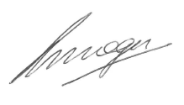

**CATRIONA ROGERS**

**CHARTERED ACCOUNTANT**

Ref: CJR:PW

**Company Name: Penrith Nominees (NSW) Pty Limited**

**ACN: 129 794 298**

**Address: 13 Worcester Street**

**COLLAROY NSW 2097**

**Date: 22 February 2021**

PRESENT: Melissa Dempsey - Chairperson

Darryl James Gilmartin

MINUTES OF PREVIOUS

MEETING: The minutes of the previous meeting of directors were read and confirmed.

SOLVENCY: It was resolved after reviewing the result of the company for the previous year, reviewing the cash flow budgets for the ensuing year and considering the ability of the company to realise assets that the company would be able to pay its debts as and when they fall due.

CLOSURE: There being no further business the meeting was closed.

__________________________ **X MD**

Melissa Dempsey

Chairperson



Tax Invoice Number: 2217152

22 February 2021

The Directors

Penrith Nominees (NSW) Pty Limited

13 Worcester Street

**COLLAROY NSW 2097**

**melgilmartin@hotmail.com**

**MEMORANDUM OF FEES**

**TO: PROFESSIONAL SERVICES**

Consideration of Annual Company Statement received from ASIC.

Preparation & corrections and lodgement of Form 484 where necessary.

Forwarding documents to you for signature and lodgement.

$250.00

Add: GST $25.00

Total amount now due **$275.00**

With Compliments,

For your convenience below are our bank account details should you wish to directly deposit money into our account.

Please note if you are paying via Internet Banking, can you please list the invoice number of the invoices you are paying.

Account Name: The Rogers Group Limited Partnership

Account Number: 55927 8329

BSB: 082 401

National Australia Bank

Tax Invoice Number: 2217152

22 February 2021

The Directors

Penrith Nominees (NSW) Pty Limited

13 Worcester Street

**COLLAROY NSW 2097**

**melgilmartin@hotmail.com**

**MEMORANDUM OF FEES**

**TO: PROFESSIONAL SERVICES**

Consideration of Annual Company Statement received from ASIC.

Preparation & corrections and lodgement of Form 484 where necessary.

Forwarding documents to you for signature and lodgement.

$250.00

Add: GST $25.00

Total amount now due **$275.00**

With Compliments,

For your convenience below are our bank account details should you wish to directly deposit money into our account.

Please note if you are paying via Internet Banking, can you please list the invoice number of the invoices you are paying.

Account Name: The Rogers Group Limited Partnership

Account Number: 55927 8329

BSB: 082 401

National Australia Bank