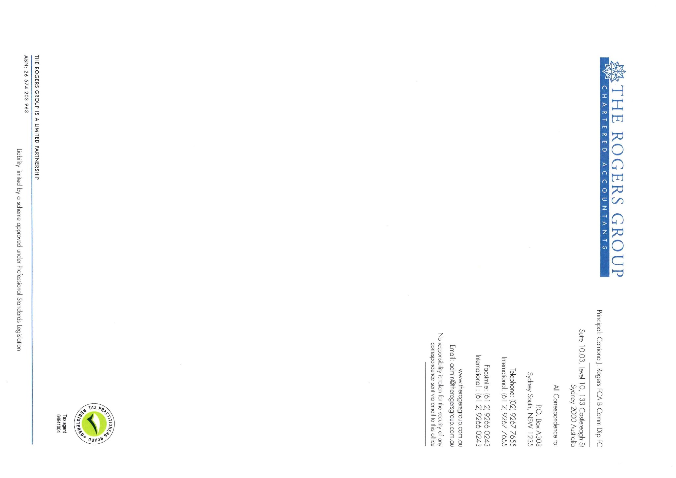

Tax Invoice Number: 2216973

26 November 2020

The Trustees

The Gilmartin Superannuation Fund

13 Worcester Street

**COLLAROY NSW 2097**

**Melgilmartin@hotmail.com**

**MEMORANDUM OF FEES**

**TO: PROFESSIONAL SERVICES**

Professional services for the period 5th September 2019 to 8th November 2020

Preparation of the Financial Statements for the Gilmartin Superannuation Fund for the year ended 30 June 2020

Preparation and lodgement of the Income Tax Return for the year ended 30 June 2020

Preparation of the Audit file

Liaising with the Auditor

$2,200.00

GST thereon $220.00

Total now due **$2,420.00**

With Compliments,

For your convenience below are our bank account details should you wish to directly deposit money into our account.

Please note that if you are paying via Internet Banking, please note the Invoice number of the Invoice you are paying.

Account Name: The Rogers Group Limited Partnership

Account Number: 55927 8329

###### BSB: 082 401

###### National Australia Bank

Ref: CJR: MK