- Our pricing for BTC and ETH is based on the price feed from NBOC. These prices are imported into our software daily and allow for a consistent market value of cryptocurrency across all of our clients regardless of which broker or platform they are using. Accordingly we have not used btc market’s pricing which could vary for a number of reasons including a different exchange rate being used. Any differences will be immaterial.
FAQ - NBOC

https://www.bglcorp.com/2022/03/07/bgl-collaborates-with-cointree-to-provide-cryptocurrency-price-feed-nboc/

BTC
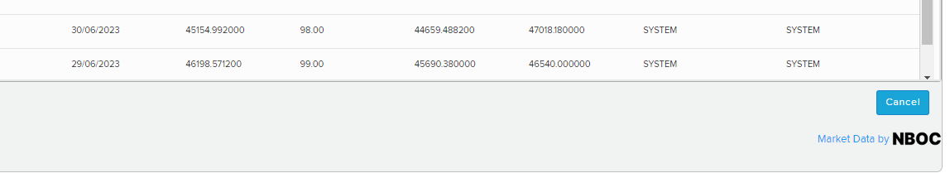
ETH
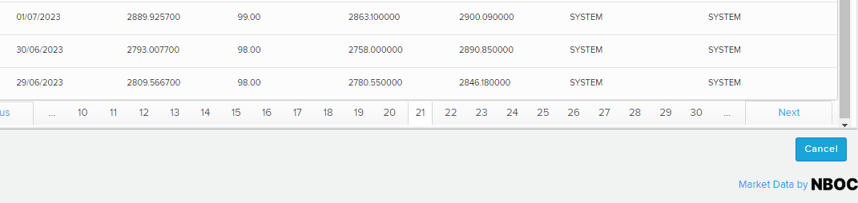

- Updated trustee declaration re cryptocurrency attached.

