Taxiz & Refunz ABN 91 418 239 197
James Shaw
Tax Agent, Chartered Accountant
B.Com (NZ), ACA (AUS) & (NZ)
3 Kelba Street, North Balwyn, Victoria 3104
jamshaw@ozemail.com.au
Ph. 03 9859-8774 & Fax 03 9859-8704

Dated 24th July 2020

To Whom it may concern

We are the accountants for GFSF AUSTRALIA PTY LTD ATF Gupta Family Superannuation Fund.

We confirm that GFSF AUSTRALIA PTY LTD being a non trading entity as trustee of The Gupta Family
Superannuation Fund is trading profitably with no contingent liabilities.

Should you require any additional information please do not hesitate to contact our office.

Regards,

James F Shaw…Chartered Accountant

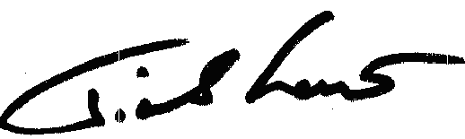

Institute of Chartered Accountants in Australia & New Zealand
Liability limited by a scheme approved under P I legislation

