**MINUTES OF TRUSTEES MEETING OF**

**Ross & Lynley Stewart Private Pension Fund**

**DATE:** 26-08-2020

**HELD AT:** 13 Birralee Loop Innaloo WA 6018

**PRESENT:** Ross Donald Stewart Lynley Margaret Stewart

**MINUTES:** The Chairperson reported that the minutes of the previous meeting had been signed as a true record.

**ANNUAL AUDIT**: It was resolved unanimously that the Fund is to be wound up and final Financial Reports and Returns for year ended 30 June 2020 be forwarded to Tony Boys to conduct the annual audit of the fund.

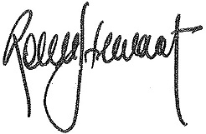**CLOSURE:** There being no further business the meeting was closed.

**CONFIRMED:** --------------------------------------------------------------

(Chairperson)