Denboer Holdings Pty. Ltd.  2 Waterview Parade,  Ascot.  Western Australia. 6104.  AUSTRALIA. | Perth | Phone : 61 8 92776441  Fax : 61 8 92776441  Mobile : 61 419 577 644  Email : annbram@westnet.com.au  Wednesday, July 29, 2026

ABN No 87 204 280 671

To : Tony Boys

Subject . The Roduna Superannuation Fund

DETAILS

Please be advised that the above fund has invested with us the sum of Two hundred & eighty four, thousand, eight hundred and eighty two dollars & six cents as of the 30th of June 2021.

$284,882,06

Also wish to advise that Rodney and Una Reynolds are not relatives of ours.

Trust this meets with your approval,

Yours sincerely,
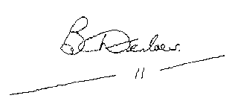

Brent Denboer

Director of Denboer Holdings Pty Ltd.

