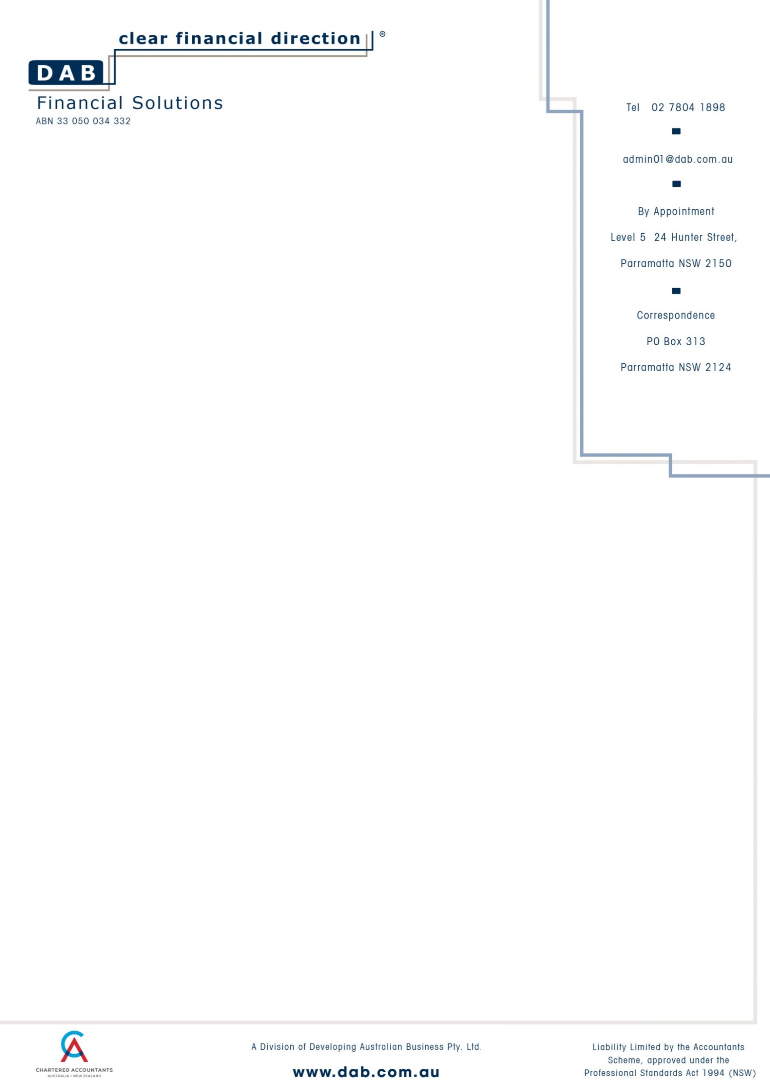

11 April, 2023

Dr Larissa Grund
Director
L Grund Pty Ltd As Trustee for
Grund Superannuation Fund
460 Brush Road
FOUNTAINDALE NSW 2258

Dear Larissa,

Re: Grund Superannuation Fund Audit Engagement Letter
Objectives and Scope of the Audit
You have requested that we audit the financial statements of the SMSF for the year ended 30 June 2022. We are pleased to confirm our acceptance and understanding of this engagement by means of this letter.

Our audit will be performed in accordance with Australian Auditing Standards, the Superannuation Industry (Supervision) Act 1993 (SISA) and the Superannuation Industry (Supervision) Regulations (SISR) with the objective of expressing an opinion on the financial report and the fund’s compliance with the specified requirements of the SISA and the SISR.
Our Responsibilities
We will conduct our audit in accordance with Australian Auditing Standards. Those Auditing Standards require that we comply with relevant ethical requirements relating to audit engagements and plan and perform the audit to obtain reasonable assurance as to whether the financial report is free from material misstatement.
An audit involves performing audit procedures to obtain audit evidence about the amounts and disclosures in the financial report. The procedures selected depend on the auditor’s judgement, including the assessment of the risks of material misstatement of the financial report, whether due to fraud or error. An audit also includes evaluating the appropriateness of the financial reporting framework, accounting policies used and the implementation and operation of accounting and internal control systems that are designed to prevent and detect fraud and error, as well as evaluating the overall presentation of the financial report.
Because of the inherent limitations of an audit, together with the inherent limitations of internal control, there is an unavoidable risk that some material misstatement may not be detected, even though the audit is properly planned and performed in accordance with Australian Auditing Standards.
In making our risk assessments, we consider internal control relevant to the entity’s preparation of the financial report in order to design audit procedures that are appropriate in the circumstances, but not for the purpose of expressing an opinion on the effectiveness of the entity’s internal control. We will, however, communicate to you in writing any significant deficiencies in internal control relevant to the audit of the financial report that we have identified during the audit.

Trustees’ Responsibilities
Our audit will be conducted on the basis that the trustee(s) acknowledge and understand that they have responsibilities:
- For the preparation of the financial report that gives a true and fair view in accordance with the Australian Auditing Standards, other mandatory reporting requirements and the SIS Act and SIS Regulations is that of the trustee(s);
- For such internal control as the trustee(s) determine is necessary to enable the preparation of the financial report that is free from material misstatement, whether due to fraud or error; and
To provide us with:
  - Access to all information of which the trustees are aware that is relevant to the preparation of the financial report such as records, documentation and other matters;
  - Additional information that we may request from the trustees for the purpose of the audit; and
  - Unrestricted access to persons within the entity from whom we determine it necessary to obtain audit evidence.
As part of our audit process, we will request from trustees written confirmation concerning representations made to us in connection with the audit.
Australian Auditing Standards require that we determine whether the financial reporting framework applied in the preparation of this special purpose of financial report is acceptable. If we determine the financial reporting framework to be unacceptable, we will not be able to undertake the audit engagement unless the framework is amended and then determined to be acceptable.
If a qualified audit report is to be issued following the completion of our audit, we will advise the details to you in a timely manner and prior to the issue of our report.
Audit of SIS Compliance
For the year ended 30 June 2022, we are required to form an opinion in respect of compliance with certain aspects of SIS. Our report must refer to the following sections and regulations:
Sections: 17A, 35AE, 35B, 35C(2), 52, 62, 65, 66, 67, 67A, 67B, 82-85, 103, 104, 104A, 105, 109, 126K
Regulations: 1.06(9A), 4.09, 4.09A, 5.03, 5.08, 6.17, 7.04, 8.02B, 13.12, 13.13, 13.14, 13.18AA, 13.22C
Report on Significant Matters
Under section 129 of the SISA we are required to report to you in writing. If during the course of, or in connection with, our audit, we become aware of any contravention of the Act or Regulations which we believe has occurred, is occurring or may occur.
We are also required to report to the ATO, as regulator, any contravention of the SISA and the SISR, where we believe the contravention may affect the interests of the members of beneficiaries of the fund.
In addition, we are also required under section 130 to report to you if we believe the superannuation fund may be, or may be about to become, in an unsatisfactory financial position. If we are not satisfied with your response as trustee(s) as to the action taken to rectify the situation or we receive no response, we are obliged to report the matter to the ATO.
A failure on the part of the trustee to rectify these breaches to the satisfaction of the ATO may result in significant penalties to the trustee and the fund itself.
In addition to our report on the financial statements, we will also report to you any material weaknesses in the fund’s system of accounting and internal control which come to our notice during the course of our audit.
Quality Control
The conduct of our audit in accordance Australian Auditing Standards means that information acquired by us in the course of our audit is subject to strict confidentiality requirements. Information will not be disclosed by us to other parties except as required or allowed for by law or professional standards, or with your expressed consent.
Our audit files may, however, be subject to review as part of the quality control review program of Regulators and or Professional Bodies which monitors compliance with professional standards by its members.
We advise you that by signing this letter you acknowledge that, if requested, our audit files relating to this audit will be made available under this program. Should this occur, we will advise you. The same strict confidentiality requirements apply under this program as apply to us as your auditor.
Independence/Conflict of Interest
We have established policies and procedures designed to ensure our independence, including policies on holding financial interests in the superannuation fund and other related parties, rotation of audit partners, business relationships, employment relationships, and the provision of non-audit services in accordance with professional statement APES 110 – Code of Ethics for Professional Accountants.
Outsourced Services
We do not use any outsourced services in overseas locations when conducting client assignments.
Data Storage
We use data storage located in the office but it may be replicated to other locations.
Accepting our services as part of this engagement agreement indicates your acceptance of the use of outsourced services, cloud hosted software and outsourced data storage under the conditions outlined above.
Limitation of Liability
Our firm’s liability to you or any other user of the audit report is limited by a Scheme approved under Professional Standards Legislation.
Other
We would appreciate acknowledgement of terms and conditions set out in this letter. Please note that this letter will be effective for future years unless the terms of the engagement are altered by future correspondence.
Please sign and return the attached copy of this letter to indicate that it is in accordance with your understanding of the arrangements for our audit of the financial report.
If you have any queries in relation to this please contact me.

Yours sincerely

ANTHONY BOYS – REGISTERED COMPANY AUDITOR
DATED:
Signed document to be returned to P.O. Box 3376 Rundle Mall SA 5000

To: MR ANTHONY BOYS
I/We hereby confirm your appointment as Auditor under the above terms of engagement.
For and on behalf of Trustee as trustee for the Grund Superannuation Fund
Signed & Dated

