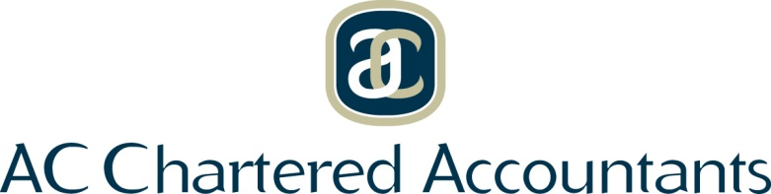

PO Box 5550 CANNING VALE SOUTH, Western Australia 6155

admin@accharteredaccountants.com.au

Mobile: 0404 311 455

25th May 2022

**AUTHORISATION TO DEDUCT FEE**

I, **Josie Gorman,** authorise Andy Coleman to deposit my Super Fund tax refund into his bank account, deduct the sum of **$2 200.00** being the charges for his professional services rendered, and to forward any balance to me.

My banking details are: BSB: _______________ Account Number: ______________________

Account Name____________________________

-----------------------------------------------------------

**JOSIE GORMAN**