Good afternoon Tony,

We have requested the trustees contact the Share Registry for the holding confirmation however the Trustees have only provided the below screenshot. 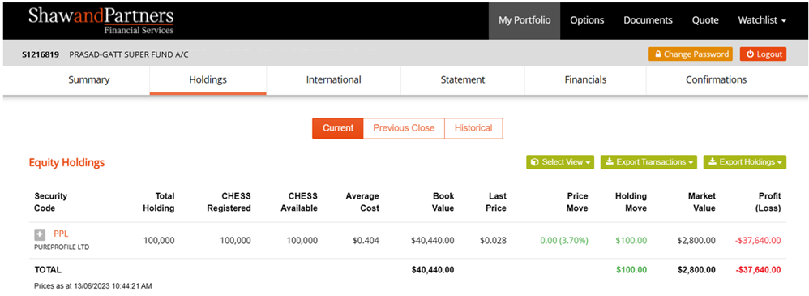

The only confirmation that we were able to obtain was included in the original documents submitted for Review at F1 on page 1. This was the only type of confirmation we were able to obtain from the Share Registry and covers all transactions from 1 January 2017 through to 30 May 2023.