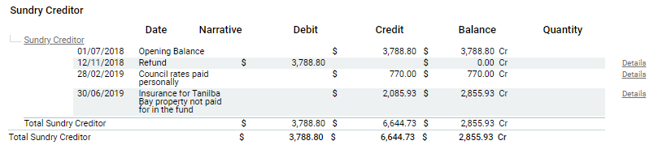

Explanation of Creditors:

$770 was accidently paid external to the superfund. This was a council rates notice for 40 Lloyd George Grove, Tanilba Bay.

Same thing with the insurance. Super fund to reimburse Bernie for paying the invoices.