Related Party (Trust) Declaration

Superfund’s Name: Diltan Superannuation Fund
Tax File Number: 955272018
Date: 04/05/2018
Investment in: Ferndale development

RE: Investment with private unit trust
I/We hereby confirm that the trustees are not related party to abovementioned trust. We understand that SIS act defines a “related trust” as a trust that is controlled by a related party. A related party can be one of the following;
- A member of the fund
- A relative of a member or their spouse
- A standard employer-sponsor of the fund
- A part 8 associate of a member. A “Part 8 associate” is defined in terms of an individual, partnership or company as the primary entity (SIS Act S70B to 70E). Part 8 associates are those entities that are relatives of the individual, partners, companies that are controlled or majority-owned, or entities that control the primary entity.
“Control” is defined as following;
- having greater than 50% of the income or capital rights in the trust, or
- a trustee acting in accordance with the wishes of a person, including where that person has the power to appoing and remove the trustee of the trust.

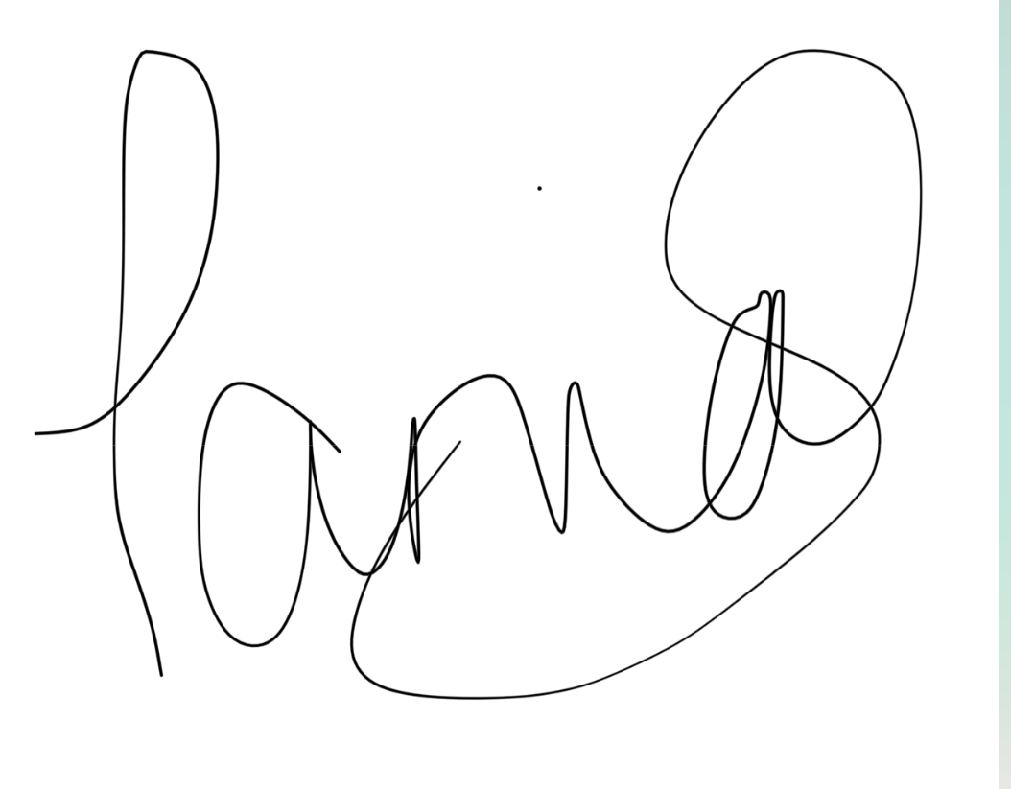 4/5/2018

Trustee’s Signature Date

Tania Sedevcic

Trustee’s Name

Trustee’s Signature Date

Trustee’s Name

