30 July 2026

Mr Charles Hore and Mrs Denise Sloan
Hore & Sloan Family Superannuation Fund
44 Anchorage Parade
Shell Cove NSW 2529

Dear Charles & Denise,

RE: SUPERANNUATION FUND TAX RETURN AND FINANCIAL STATEMENTS

Please find enclosed the signing pages for the financial report and tax return for the above entity for the year ended 30 June 2022.

Please review the financial report and tax return that were emailed to you to ensure that they are to your satisfaction.

Record keeping
The tax law requires that you keep all documentation that relates to the tax return, generally for at least five years (calculated from the date the records were prepared or obtained, or from the date the transactions or acts to which the records relate were completed, whichever is the later).

The Tax Office regularly conducts tax audits, including business record keeping audits and substantiation audits, over a wide range of taxpayers and it is essential that all supporting documentation is retained for the period specified to enable the figures in the tax return to be verified.

Documents for Signature
Please sign and return the documents where indicated.

Tax position for the year ended 30 June 2022
Based on the tax return being assessed as lodged, there will be a tax refund of $213.09 which includes the Tax Office supervisory levy of $259. Further, based on the Business Activity Statement completed, GST of $239 is refundable to the SMSF.

Should you have any queries please do not hesitate to contact me.

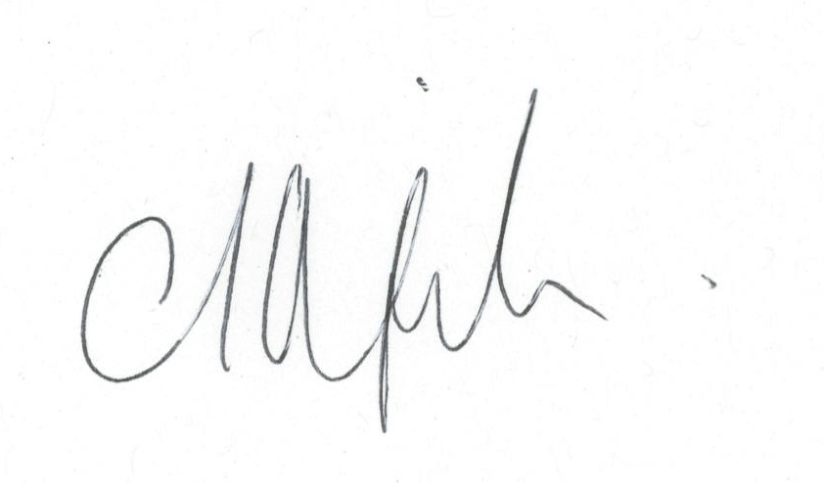
Yours sincerely

Troy Mojsoski

