JMI Super Fund Investment Strategies
Minutes of the Meeting of the Directors of
JMI Investment Strategies Pty. Ltd.
ACN 604 912 781 as Trustee

Venue | 10 Palomino Drive, Mudgeeraba Qld 4213
Date | 30 June 2021
Time | 09:00
Present | Ivan Mihalic  Joleen Mihalic
Chair | Ivan Mihalic

Investment Strategy:
- Noted that in accordance with section 52(6)(a) of the Superannuation Industry (Supervision) Act 1993 (Cth) and regulation 4.09(2) of the Superannuation Industry (Supervision) Regulations 1994 (Cth), the trustee of the fund must formulate, review regularly and give effect to an investment strategy that has regard to the whole circumstances of the fund.
- Noted that the investment strategy of the fund dated 2 December 2019 has been reviewed and considered for its ongoing appropriateness.
- Noted that in reviewing the investment strategy, the trustee considered whether to hold a contract of insurance for each of the members, and resolved to leave the current arrangements unchanged and consider this matter again as soon as practicable.
- Resolved that the trustee considers that the investment strategy dated 2 December 2019 is still appropriate for the fund.

Signed as a true record of the meeting:
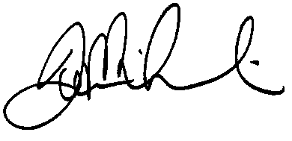
________________________________________

Chair

