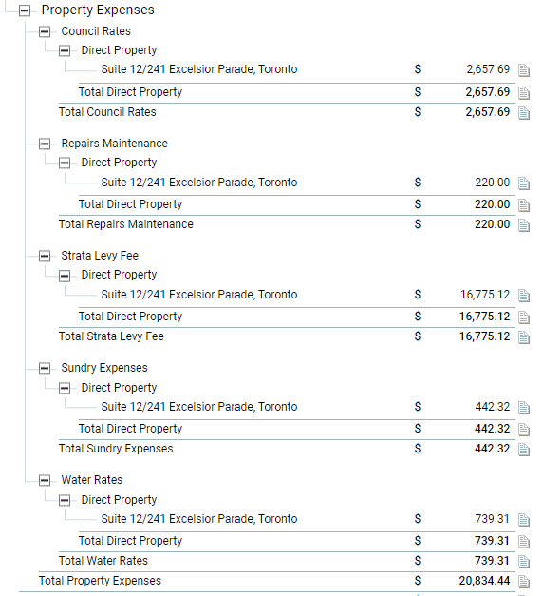

Note: Fund couldn’t afford the property expenses during the 2020 FY.

Upon sale, a number of the outstanding invoices were paid.

Strata fees were particularly high, some had be accrued in 2019, remainder was incurred in 2020.