D S Stephens & Co
Certified Practicing Accountants
PO Box 333, Frenchs Forest, NSW 1640

Liability limited by a scheme
Under Professional Standards Legislation

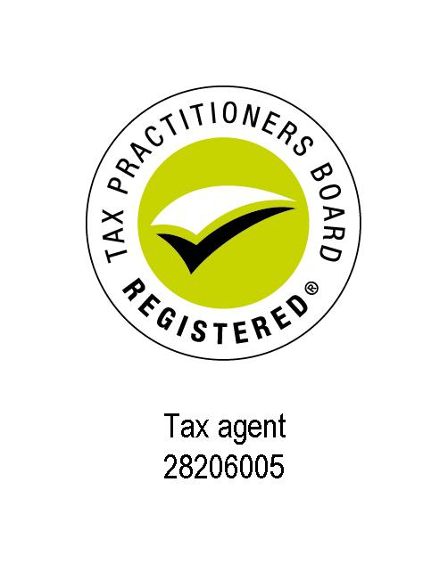

1st July 2019

Dear George,

This letter is to confirm our understanding of the terms of our engagement and the nature and limitations of the services that we provide.

Purpose, Scope and Output of the Engagement
This firm will provide accounting services, which will be conducted in accordance with the relevant professional and ethical standards issued by the Accounting Professional & Ethical Standards Board Limited (APESB). The extent of our procedures and services will be limited exclusively for this purpose only. As a result, no audit or review will be performed and, accordingly, no assurance will be expressed. Our engagement cannot be relied upon to disclose irregularities including fraud, other illegal acts and errors that may exist. However, we will inform you of any such matters that come to our attention.

This engagement includes financial statements and income tax returns which will be prepared for distribution to you. There is no assumption of responsibility for any reliance on our report by any person or entity other than yourself and those parties indicated in the report The report shall not be inferred or used for any purpose other than for which it was specifically prepared. Accordingly, our report may include a disclaimer to this effect.

Period of Engagement
This engagement will start on 30th June 2019. The first period for which we will be responsible is tax year ending/accounts period ending 30th June 2019 . We will not deal with earlier periods unless you specifically ask us to do so and we agree.

This engagement document will be effective for future years unless we issue an amended one to you.

Responsibilities
In conducting this engagement, information acquired by us in the course of the engagement, including any information relating to your affairs whether it belongs to you or not or is provided by you or not, is subject to strict confidentiality requirements. That information will not be disclosed by us to other parties except as required or allowed for by law, or with your express consent.

We wish to draw your attention to our firm’s system of quality control which has been established and maintained in accordance with the relevant APESB standard. As a result, our files may be subject to review as part of the quality control review program of CPA Australia which monitors compliance with professional standards by its members. We advise you that by accepting our engagement you acknowledge that, if requested, our files relating to this engagement will be made available under this program.

We may collect Personal Information about you, your representatives, your clients and others when we provide services to you. If we do, you agree to work with us to ensure that we both meet the obligations that we each may have under the Privacy Act 1988 (Cth) (as amended) (Privacy Act). The obligations may include notifying the relevant person to whom the personal information relates who we are and how we propose to use their personal information. Where you have collected personal information, you confirm that you have collected the personal information in accordance with the Privacy Act, that you are entitled to provide this personal information to us and that we may use and disclose the personal information for the purpose/s we provide our services to you. We will handle personal information in accordance with the Privacy Act.

You are responsible for the reliability, accuracy and completeness of the accounting records, particulars and information provided and disclosure of all material and relevant information. You are required to arrange for reasonable access by us to relevant individuals and documents, and shall be responsible for both the completeness and accuracy of the information supplied to us. Any advice given to you is only an opinion based on our knowledge of your particular circumstances. You or your staff are responsible for

maintaining and regularly balancing all books of accounts, and the maintenance of an adequate accounting and internal control system. You have obligations under self assessment to keep full and proper records in order to facilitate the preparation of accurate returns. It is your responsibility to keep those records for five (5) years.

A taxpayer is responsible under self assessment to keep full and proper records in order to facilitate the preparation of a correct return. Whilst the Commissioner of Taxation will accept claims made by a taxpayer in an income tax return and issue a notice of assessment, usually without adjustment, the return may be subject to later review. Under the taxation law such a review may take place within a period of up to four (4) years after tax becomes due and payable under the assessment. Furthermore, where there is fraud or evasion there is no time limit on amending the assessment. Accordingly, you should check the return before it is signed to ensure that the information in the return is accurate.

Where the application of a taxation law to your particular circumstances is uncertain you also have the right to request a private ruling which will set out the Commissioner’s opinion about the way a taxation law applies, or would apply, to you in those circumstances. You must provide a description of all of the facts (with supporting documentation) that are relevant to your scheme or circumstances in your private ruling application. If there is any material difference between the facts set out in the ruling and what you actually do the private ruling is ineffective.

If you rely on a private ruling you have received, the Commissioner must administer the law in the way set out in the ruling, unless it is found to be incorrect and applying the law correctly would lead to a better outcome for you. Where you disagree with the decision in the private ruling you can lodge an objection against the ruling if it relates to income tax, fuel tax credit or fringe benefits tax. Your time limits in lodging an objection will depend on whether you are issued an assessment for the matter (or period) covered by the private ruling.

Involvement of Others
Where, as part of our engagement, the services of an external consultant or expert are required, an estimated cost and timeframe and involvement will be provided to you for your approval.

Storage of Personal Information
By signing this letter and accepting these services you acknowledge and agree that your personal information may be stored overseas.

Fees
The fee arrangement is based on the expected amount of time and the level of staff required to complete the accounting and taxation services as agreed. The fee is expected to be approximately $1,200 excluding miscellaneous expenses which are incurred to complete the engagement. This fee arrangement may be subject to change.

Limitation of Liability
Our liability is limited by a scheme approved under Professional Standards Legislation. Further information on the scheme is available from the Professional Standards Councils’ website: psc.gov.au.

Ownership of Documents
All original documents obtained from you arising from the engagement shall remain your property. However, we reserve the right to make a reasonable number of copies of the original documents for our records.

Our engagement will result in the production of financial statements and income tax returns. Ownership of these documents will vest in you. All other documents produced by us in respect of this engagement will remain the property of the firm, subject to any statutory obligations.

The firm has a policy of exploring a legal right of lien over any client documents in our possession in the event of a dispute. The firm has also established dispute resolution processes.

Confirmation of Terms
Please sign and return the attached copy of this letter to indicate that it is in accordance with your understanding of the arrangements. This letter will be effective for future years unless we advise you of any change.

Yours sincerely,
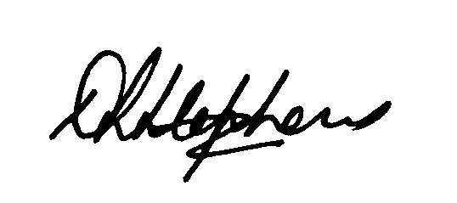

Principal

Acknowledged on behalf of MAKOKOU Self Managed Super Fund by:

Signature of client
Date

