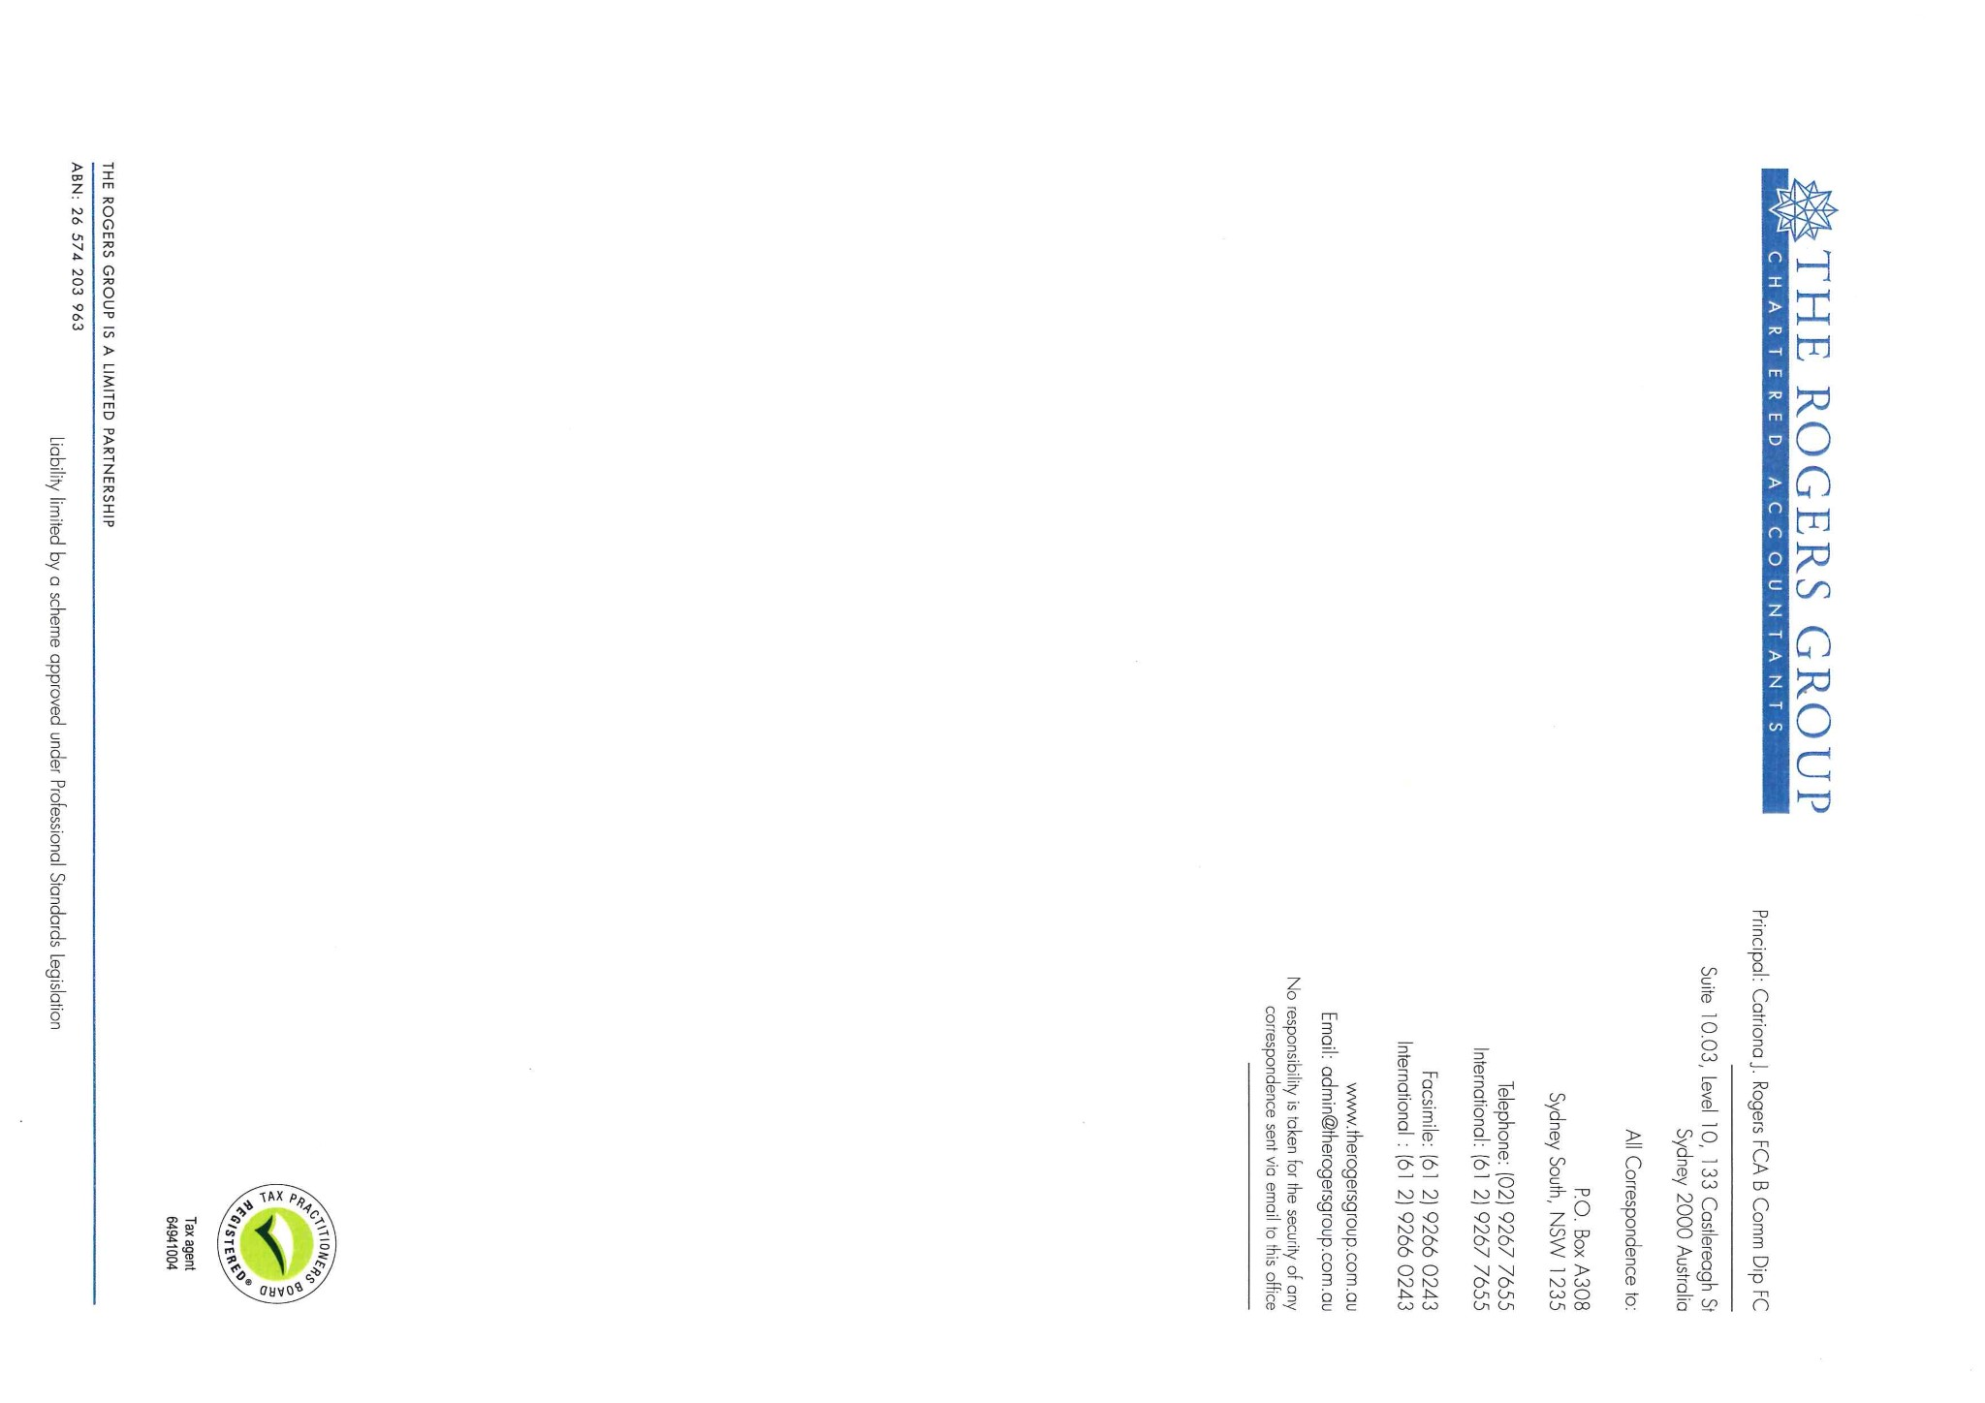Tax Invoice Number: 2216795

13 August 2020

The Trustees

Hillcrest Superannuation Fund

87 Boundary Road

**WAHROONGA NSW 2076**

**Vangell.rafael@vcglobalpartners.com**

**MEMORANDUM OF FEES**

**TO: PROFESSIONAL SERVICES**

Preparation of the accounts for the years ended 30th June 2020

Preparation of the Income Tax Return for the years ended 30th June 2020

Liaising with the auditor in relation to the accounts.

$2,500.00

GST thereon $250.00

Total now due **$2,750.00**

With Compliments,

For your convenience below are our bank account details should you wish to directly deposit money into our account.

Please note that if you are paying via Internet Banking, please note the Invoice number of the Invoice you are paying.

Account Name: The Rogers Group Limited Partnership

Account Number: 55927 8329

###### BSB: 082 401

###### National Australia Bank

Ref: CJR: MK