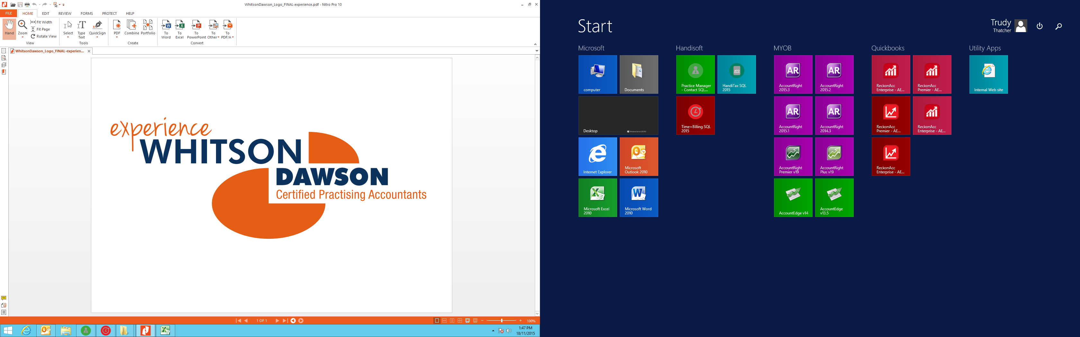

**QUERY SHEET**

**CLIENT NAME Adair superannuation Fund**

**PERIOD ENDED** 30/06/2019

**PREPARED BY Ian Fanning**

1. I advise that the Sundry Liability of $16,753 is accumulated depreciation. The movement of the account is as follows: 30/06/2018 Balance 15,472 add 2019 Depreciation $1,281 30/6/2019 Balance is $16,753. This balance is not a creditor.
2. This is the format of the chart of accounts for Supermate Software I do not particularly agree with this format but I need to work with what I have got.