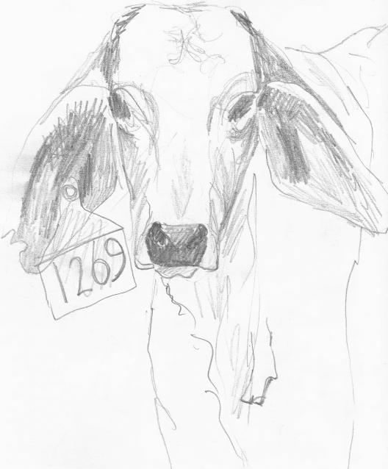

**The Neubecker Trust**

**611 Lower Waterloo Rd e-mail: rex.jen@hotmail.com**

**Waterloo, Qld. 4673 ABN: 81 873 959 625**

**phone: (07) 41561638 BSB:142-001**

**m. 0434 000 285 a/n. no.: 1347579-00**

**To BeMaRe Superfund Pty Ltd**

**Waterloo**

**ABN: 90 429 037 681**

**Invoice No. 149**

**Date 5/09/2022**

|  |  |  |  |  |
| --- | --- | --- | --- | --- |
| Date | Number | Description | GST | Total |
| 1/7/2021-30/06/2022 |  | Giant Rats Tail spraying and regrowth control  20hrs contract spraying @$40/hour |  | 8 000 |
|  |  | Regrowth clearing 20hrs @ $100/hour |  | 2 000 |
|  |  | Improved Pasature preparation and seeding 10hrs@$150/hour |  | 1 500 |
|  |  |  |  |  |
|  |  |  |  |  |
|  |  |  |  |  |
|  |  |  |  |  |
| Total |  |  | Subtotal | 11 500 |
| Signed |  |  | GST | 1 150 |
|  |  |  |  |  |
|  |  |  | Total due | 12 650 |

Invoice No.

Date